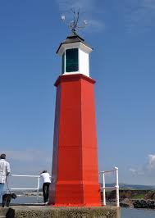

Watchet Harbour Community Bookshop,
7, The Esplanade, Watchet.

Grant Application Form

(Please note: All information provided on this form will be treated in the strictest confidence and will only be made available to the Committee members of the bookshop.)

Dear Applicant,

Please complete this form in as much detail as possible, to enable us to give full consideration to your application. This will usually be at our next monthly meeting. Please complete all sections and sign on the back page. We may ask for further information. We will also ask for evidence of the use of any grants given.

- Organisation applying for a grant:

___________________________________________________________

- Your name and relationship to organisation:

___________________________________________________________

- Address: ___________________________________________________-

___________________________________________________________

- Contact telephone number _________________________

Email address ____________________________________

- What is the purpose of the grant?

_____________________________________________________________________________________________________________________________________________________________________________________________________________________________________________________________________________________________________________________________________________________________________________________________________________________________________________________________________________________________________________________________________________________________________________________________________________________________________________________________________________________________________________________________________________________________________________________________________________________________________________________________________________
- What is the total cost (or estimate) of the goods or services needed?

£____________

Please give details of costings.

- What is the amount of grant that you are requesting?

£ __________

- Are you requesting, or have you already obtained, other funding towards the total cost? Please give details.

- Is there any further information you wish to give to help our decision?

In the event of a successful application, please advise to whom a cheque should be made payable.

_____________________________

Signature: __________________ Date ______________

For use of Bookshop Committee:

